- Begin by going to the FBISD website at: https://www.fortbendisd.com/family-access  - Click on the “LOGIN TO FAMILY ACCESS” icon. |   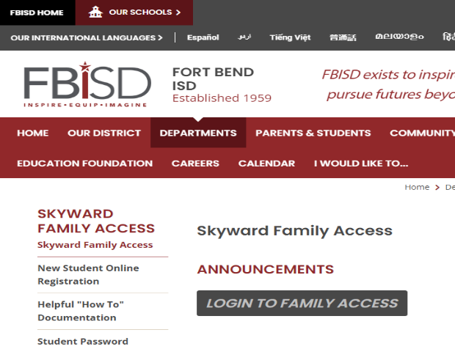
- When the login screen opens,  type in your Parent login and password and click on the Sign In button. | 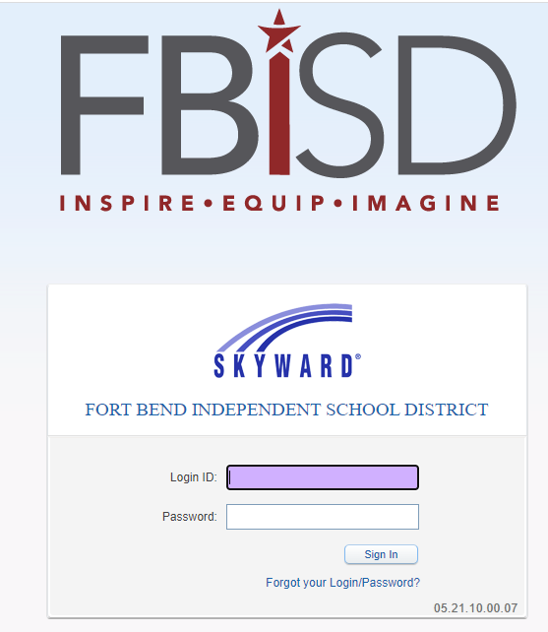
- Open the dropbox by clicking on the small arrow that pointing down.  The Family Access screen offers you the ability to view one or all of your children from one convenient screen.  - Then select the Home tab on the Easy  Access Toolbar to access the  Family Access Home Page. | 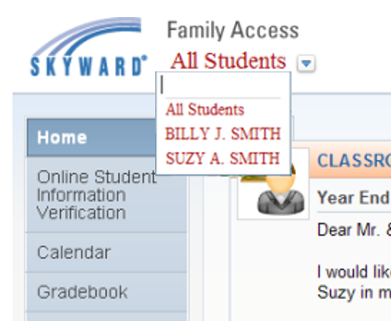
- Click the Fee Management tab  on the Easy Access Toolbar from the left side menu to make payments for your student(s). | 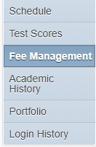
- Select “Make a Payment”  - Make sure of the Fee Description/Amount Charged: IT departments placed payment for Lending Library Devises in this web store to provide a convenient way for parents to pay. | 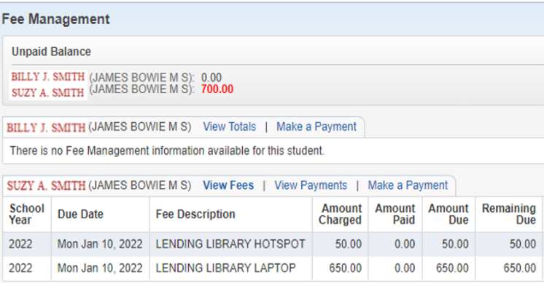
- This will take you to the Fort Bend ISD web store. The Fort Bend ISD Web Store is a hosted online payment center.  - Choose "ADD TO CART" for each item.  - You can add all the items to pay for multiple students on one screen for a single check-out. | 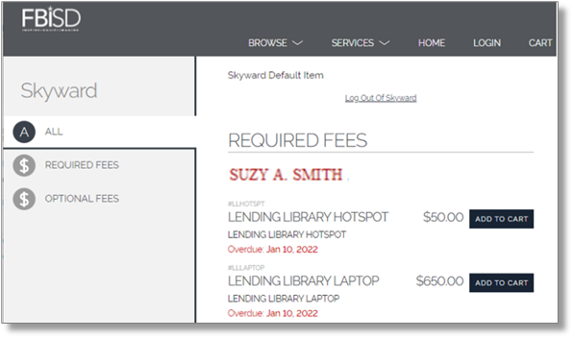
- Once you place an item in your cart, you may use the large back-arrow at the top of your cart to return to previous page and add the next item.  - When you “CHECK OUT”, you will log in to your account. If this is your first payment in the Fort Bend ISD web store, create your account and enter the email address where you want the receipt sent and click Sign in. If you are a returning customer, enter the password you established on your first visit and click Sign in. | 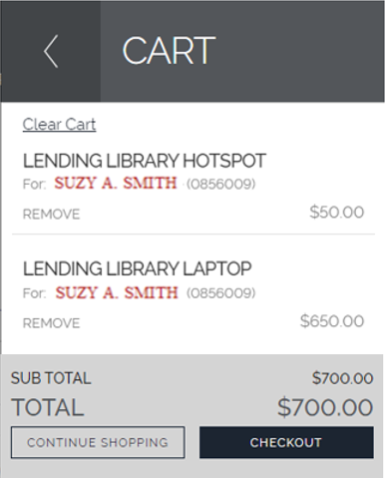
- We accept Discover, MasterCard or VISA (debit, credit or check card). If your payment is not accepted there will be a red message on screen to give the reason provided by the card processing service. | 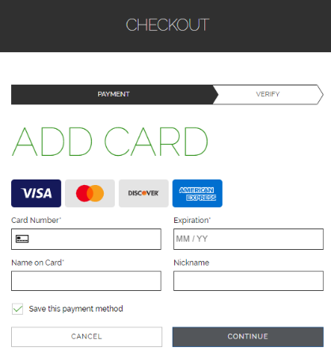
- As you complete the checkout process, a receipt will show on screen. Also, during checkout, you are required to provide an email address. When the charge is authorized, a confirmation email is sent immediately to the email address you have provided.  - Click “MY ACCOUNT” then “My Setting” to see your order history. Click on any item and you will see your printable receipt. | 